Data Integration With ORM stack

Contents

1. Introduction 3
2. Workflow diagram to deploy the stack 3
3. Create stack for Data Integration 4
4. Plan the Job 6
5. Apply the Job 7
6. Verify in the Console 8
7. Destroy the stack 9

Introduction

Data integration in Oracle Cloud Infrastructure (OCI) refers to the process of combining data from different sources and formats into a unified and coherent format within the OCI platform. Data Integration is a fully managed, serverless, cloud-native service that extracts, loads, transforms, cleanses, and reshapes data from a variety of data sources into target Oracle Cloud Infrastructure services.

Workflow diagram to deploy the stack

Below diagram shows how the Terraform Artifact are applied in the OCI. While creating a ORM stack, using terraform deliverables Init, Plan and Apply is the flow to provision the resource in the OCI. We can have the deliverables in any of below.

- GitLab/GitHub Repo
- Bitbucket
- Can be in folder/.zip in the local disk
- Object Storage Bucket
- Can be in compartment
- Oracle provided Template


Create stack for Data Integration

Go to OCI Console Developer Services Resource Manager Stacks select the compartment Create Stack

My Configuration Folder Browse Select the “Data_Integration” folder that contains the terraform Upload

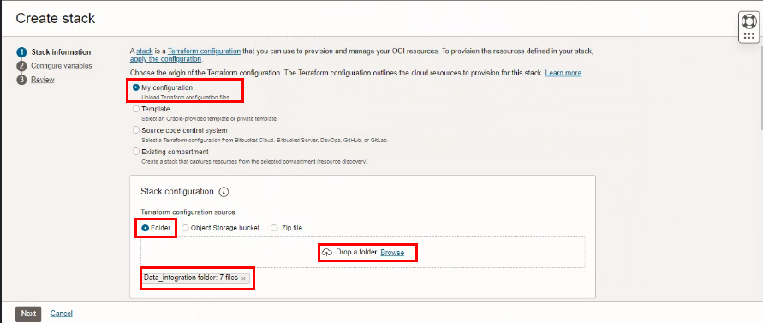

Select the parameters as per the below screen,
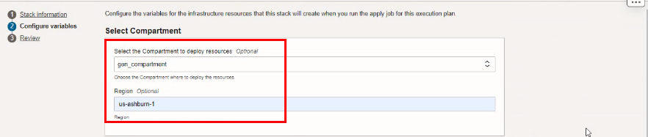
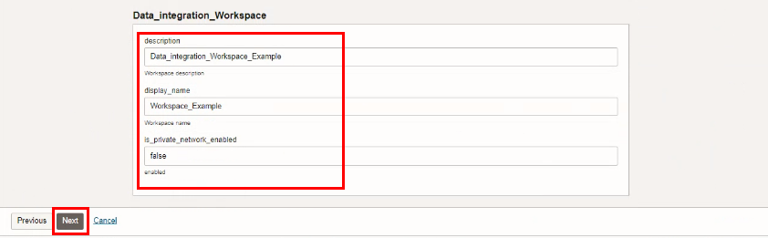
Click “NEXT”
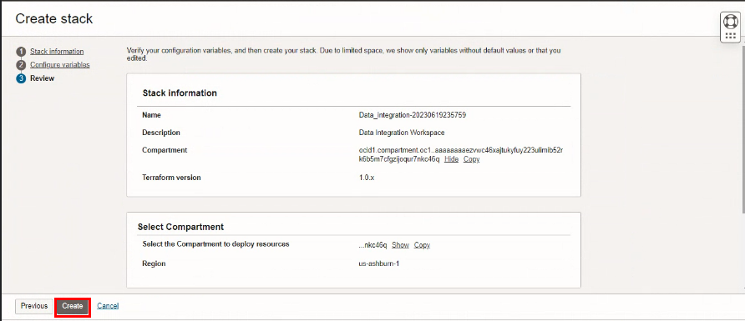
Click “CREATE”

Plan the Job

Click the “Plan”
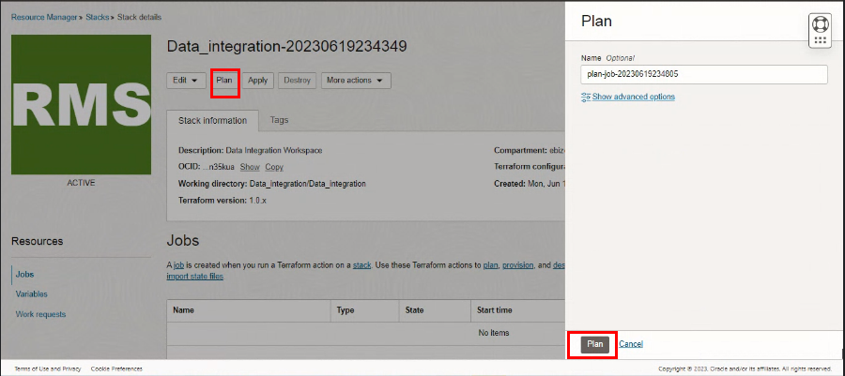
Verify the Plan is successful.
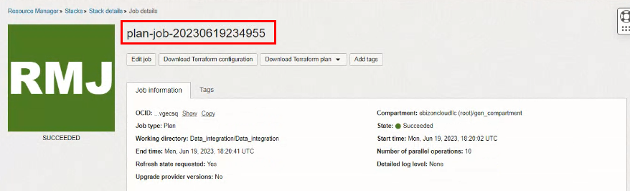
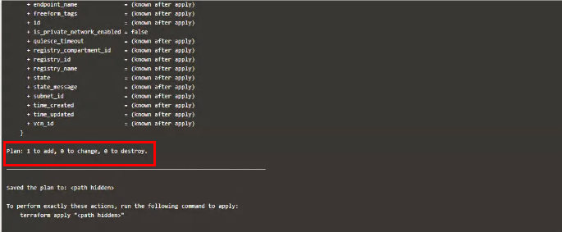

Apply the Job

Once the “plan” is success, now click “Apply”
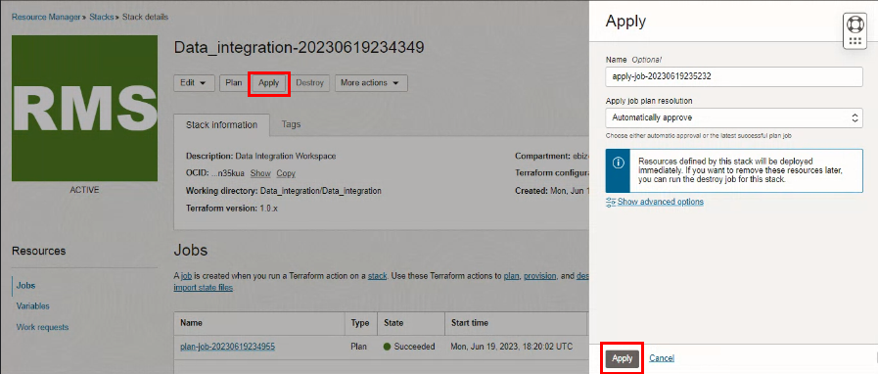

Verify the Apply is successful.
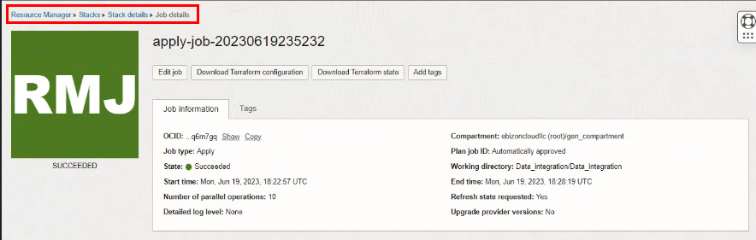
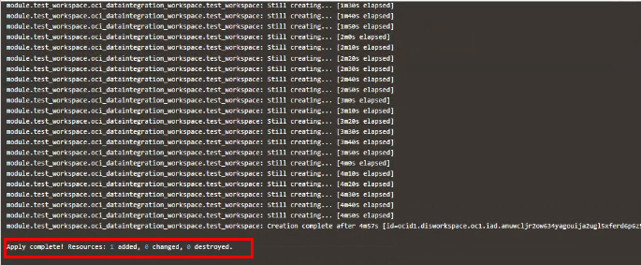

Verify in the Console

Go to OCI Console Analytics & AI Data LakeData IntegrationWorkspace

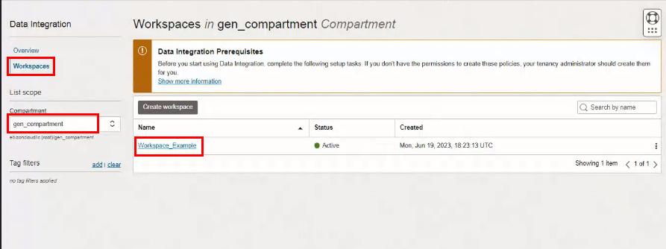

Data IntegrationWorkspace Example
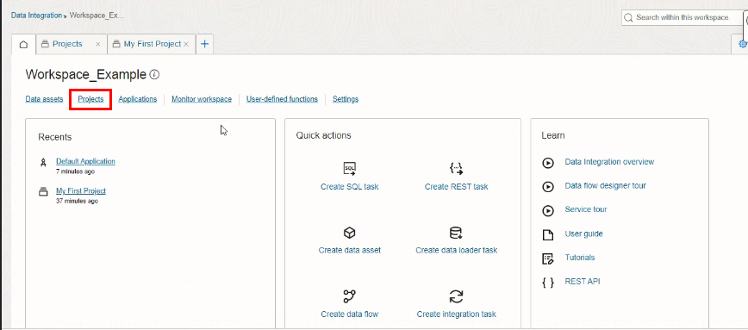
Data IntegrationWorkspace Example Projects

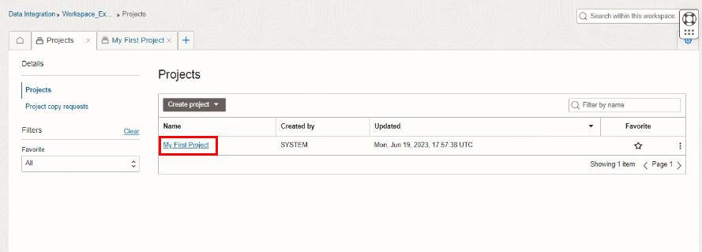

Destroy the stack

Create a destroy job in Resource Manager to release resources associated with a stack and clean up the tenancy. Once destroyed data cannot be recovered from resources.

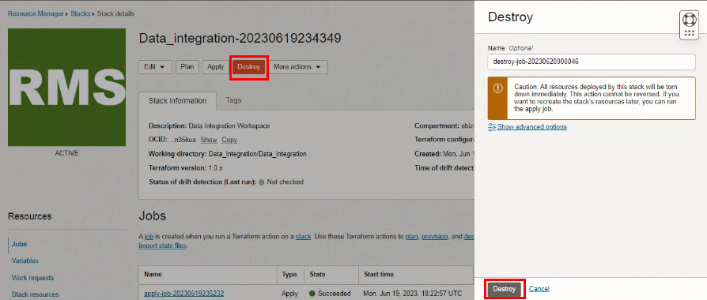

#END#

